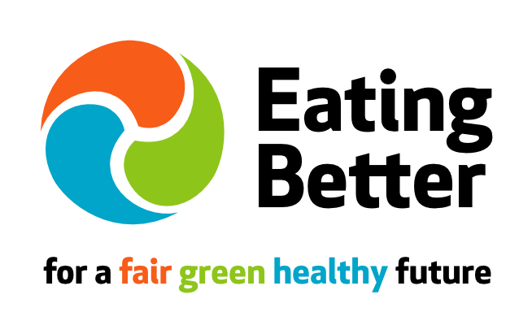
Press Release: for immediate release Tuesday 2 February 2016

Contact: Elena Salazar, Campaigns & Communications Associate, Eating Better.
Email: elena@eating-better.org Mob: 07849 051492 Twitter: @Eating_Better

Time to tackle climate change & health – 3 times a day
Eating Better calls on Government to step up to the plate for our health and the health of the planet

Today, Tuesday 2 February, Eating Better - an alliance of nearly 50 public health, environment, animal welfare, development and producer organisations (1) – launches its demands of Government – to take urgent action on the meat in our diets for the sake of our health, and the planet. (2)
With a staggering third of global GHG emissions coming from the food system, 2016 is the year policy makers need to wake up to how food and farming can help us deliver better health for people and the planet, says the Eating Better Alliance. Meat is typically the most GHG intensive part of our diet, accounting for at least 14.5 per cent of global GHG emissions – as significant as emissions from transport (3). New research says reducing meat & dairy consumption by half would reduce heart disease and cancers, and cut GHG from agriculture by up to 42% (4).
“2015 ended with an historic climate deal in Paris – to keep global temperature rise below 1.5ºC. But we haven’t a hope of avoiding catastrophic climate change if governments continue to ignore the impact of high levels of meat consumption,” says Sue Dibb, coordinator of Eating Better. “A missing trick stares us in the face three times a day – it’s what we’re eating. One vital, simple step is for people in high consuming countries, including the UK, to eat less and better meat and a greater variety of plant-based foods. This will have benefits for our health and the health of our planet.”
Eating Better is calling on policy makers in the UK, devolved administrations and EU to implement policies that help people move towards eating less and better meat and more plant based foods (5), including:
- Putting food and agriculture centre-stage in strategies to meet climate change agreements and sustainable development goals.
- Update the UK’s official dietary guidance – the eatwell plate – and associated advice to integrate sustainability messages including eating less meat.
- Introduce mandatory procurement standards for caterers to ensure that meals paid for by taxpayers in schools, hospitals, prisons, care homes and all government departments are healthy & sustainable.
- Support and encourage farming that produces meat in ways that benefit the environment, human health and animal welfare and provides a fair return for farmers.
- Align UK business growth policy for food and farming with health and sustainability including supporting innovation and growth of a more diverse range of plant-based protein options.
- End the unnecessary and dangerous routine use of antibiotics in farming.
- Work with EU institutions and Member States to support Common Agricultural Policy (CAP) reform to deliver a European Healthy Sustainable Food and Farming Policy.
Eating Better’s policy recommendations have been produced in consultation with the alliance’s 47 supporting organisations and partner networks.

Notes to Editors:

- Eating Better: for a fair, green, healthy future (www.eating-better.org) is a broad alliance, to help people move towards eating less meat and more food that’s better for people and the planet, as part of the vital task of creating sustainable food and farming systems. The alliance brings together 47 national supporting organisations and partner networks, from public health, environment, international development, animal welfare, producer, professional and faith interests including Friends of the Earth, WWF, Sustain, UK Health Forum, British Dietetic Association, Compassion in World Farming and the Soil Association (see full list: http://www.eating-better.org/about.html).

- Eating Better Policy Briefing 2016 can be downloaded here (pdf).

- See: Wellesley et al. (2015) Changing Climate: Changing Diets, Chatham House, the Royal Institute of International Affairs.

- See: Henk Westhoek et al (2016) Nitrogen on the Table: The influence of food choices on nitrogen emissions, greenhouse gas emissions and land use in Europe, Centre for Ecology & Hydrology, Edinburgh.

- Eating Better encourages a culture where we place greater value on the food we eat, the animals that provide it and the people who produce it. Eating Better supports farmers who produce meat in a sustainable way. Reducing our meat consumption – whether red, white or processed meats – while also choosing ‘better’ meat that is naturally-fed, has a known provenance and is produced to high animal welfare, environmental and quality standards can help support farmers without being more expensive for consumers.

