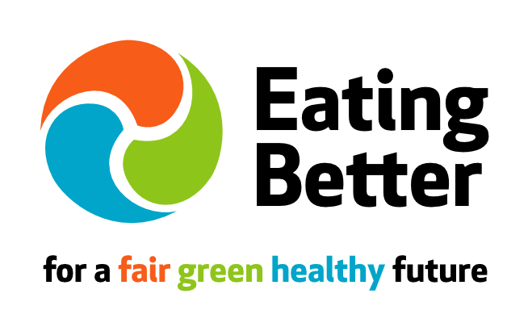

PRESS RELEASE: Embargo: 00:00 Tuesday 15 July 2014

FOODSERVICE INDUSTRY CALLED ON TO INCREASE HEALTH AND WELLBEING POLICIES

Footprint and Eating Better join forces to engage businesses on showcasing health and vitality best practice

Senior officials representing the UK’s leading foodservice companies, industry organisations and the Department of Health gathered today [15th July] to debate the latest changes to the Responsibility Deal, to hear an exclusive update from the Food Network and to discuss the business opportunities in healthy and sustainable eating.

The industry summit, headed by Corporate Sustainability Champions Footprint, hosted at Sodexo’s HG and supported by Eating Better – a leading voice on consumer diet – a leading voice on consumer diet - included representatives from some of the best-known names in the foodservice, services and hospitality industries including Aramark, Tragus, Spirit Pub Company, Coca-Cola Enterprises, and Nestlé Professional. The Health & Vitality Special Interest Group (SIG) is a non-competitive and transparent environment for the entire supply chain to exchange ideas and best practice, create closer sector relationships and collaborate on best practice around sustainable diets and the cost effectiveness this can deliver”.

Speaking at the event Nick Fenwicke-Clennell, CEO of Footprint commented:
“With one in eight meals eaten out of home it is vital that the issues of consumer health and wellbeing are taken seriously and addressed across the foodservice sector. The importance of the role of the foodservice industry in driving the agenda of consumer health and wellbeing cannot be underestimated.
“The Government’s Responsibility Deal was the very thing to galvanize all out of home food operators and huge progress has been made in just 12 months. The new targets for salt reduction, for example, is testament to the fact that there is confidence that increased pressure to innovate can be applied without harm. We are privileged to be part of the innovations taking place under the noses of the consumer who may never be aware of the great work the foodservice industry is doing.”

Key issues arising from the group’s latest meeting included a debrief from the DoH on the latest Responsibility Deal requirements for the Out of Home sector, and a look at the latest food sustainability trends, research and policies. The group also discussed the business opportunities represented by the health and sustainability agendas, as well as the barriers for operators, while Eating Better launched a new business engagement initiative.

Sue Dibb, Better Eating Coordinator says: ‘‘We want to showcase businesses leading the way whether restaurants, school and hospital food providers, employers, retailers, and food producers.

“Food businesses can help by offering more meat-free meals and creating lower- meat and more plant-based dishes that are attractive, desirable choices for customers as well as sourcing ‘better’ meat for the meat they do use that is naturally-fed, has a known provenance and is produced to high animal welfare, environmental and quality standards. This ‘less but better’ approach to meat eating can provide health and sustainability benefits while also providing cost savings.”

The date of the next summit meeting will be announced shortly.
For further information go to www.foodservicefootprint.com

For press information contact Niki Goddard at The Splash Partnership on 01225318000 or via niki.goddard@tsplashp.com

ENDS

NOTES TO EDITORS:

About Footprint
Corporate Sustainability Champion Footprint is a leading authority on the subject of sustainable supply chains in the food sector, and on circular economy. Footprint head up the Footprint Forum, THE industry member organisation for senior professionals to engage and debate core issues around business and sustainability.

Members and delegates represent the entire foodservice supply chain from source to delivery, associated industries, such as waste disposal/packaging etc, as well as agencies, Government and NGO’s. All are at a senior level in their respective organisations; those with the power of influence, be it from a corporate, media or political standpoint to initiate cultural change.

Footprint recently launched ‘Buy British, Boost Britain’ – the first campaign to call for greater support for the UK agricultural sector through local sourcing and investment.

About Eating Better
- Eating Better – for a fair, green, healthy future is a broad alliance launched with the backing of Hugh Fearnley-Whittingstall last year to demonstrate that eating ‘less and better’ meat as part of healthy sustainable diets is fairer, greener and healthier for people and the planet. Eating Better is calling for action by governments and the food industry to:
- Help people adopt diets that are better for us and the planet: by eating a greater variety of plant-based foods and less and better meat (red, white and processed).
- Support farming that produces meat in ways that benefit the environment, health and animal welfare.

- Eating Better is supported by 40 supporting organisations and partner networks including British Dietetic Association, UK Health Forum, WWF-UK, Compassion in World Farming, Oxfam, Soil Association, Forum for the Future, Sustain, Sustainable Restaurant Association, Slow Food and Friends of the Earth. See here for full list.

- There is growing expert consensus that a shift to more plant-based diets and eating less meat in high-consuming countries such as the UK can help cut heart disease and some cancers as well as slash greenhouse gas emissions and feed the world more fairly.

Allegra Strategies, Eating Out of Home, 2013

