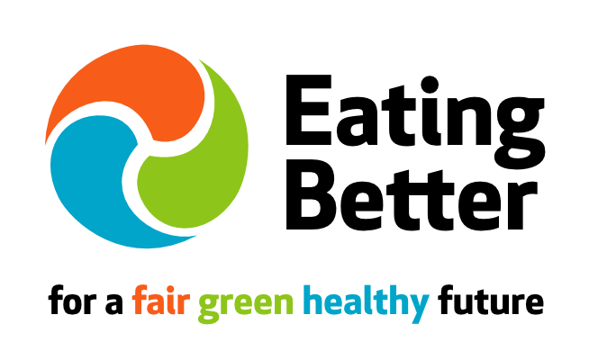

Role: Executive Director, the Eating Better alliance

Location: London office based

Hours: 4 days/30 hours a week (0.8 f/t) with potential to increase to full-time, dependent on funding.

Salary: £45,625 pro rata (£36,500). Plus 3% pension contribution

Closing date for applications: 12 noon Monday 9 April 2018

Interviews will be held: Monday 23 April 2018

Anticipated start date: June/July 2018

This hugely exciting role requires a skilled, experienced and motivated individual with experience of achieving change to lead the Eating Better alliance into its next stage of development. This is a fantastic opportunity to join a small London-based staff team and this dynamic alliance of over 50 UK-based civil society organisations working together to transform the way we eat, for a fair, green and healthy future.

Launched four years ago Eating Better is working to influence governments, businesses, civil society and others. We are making an impact to create sustainable food and farming systems by helping people move towards eating less meat and dairy and more food that’s better for us and good for the planet.

Our campaigns, research and thought leadership are creating a movement that is engaging the public, business and policy makers to take action. Our current Executive Director, Sue Dibb, will be retiring in June 2018, after leading the organisation since its inception.

You will have experience of working with a wide range of people and organisations towards measurable outcomes for sustainable food futures in the UK, and of working with a small staff team and Board to develop and fund programmes of work to deliver on strategic objectives. You will be ambitious for Eating Better and its objectives, have excellent communication and advocacy skills and sound staff, organisational, strategic, fundraising and financial management experience.

Sue Dibb, our current Exec Director, says: “This is a fantastic opportunity to lead a dynamic organisation into its next phase of development. We have an ambitious programme of work ahead that will provide scope for innovative thinking and new partnerships and projects. I’ve hugely enjoyed working with a dedicated team of people.”

About Eating Better
Eating Better (http://www.eating-better.org) is a growing UK-based alliance that is working together to help people move towards eating less and better meat.

We focus on finding solutions to one of the greatest challenges facing humankind: ensuring we can feed a growing and more affluent global population healthily, fairly and sustainably, while keeping within globally agreed climate change goals and environmental limits. There is no single solution but the evidence behind Eating Better’s focus is clear: within high meat & dairy consuming countries such as the UK, we need to shift what we eat towards diets with reduced levels (at least half current consumption) of livestock products and more plant-based foods.

Since Eating Better was launched in 2013 the need for this dietary transition has become clearer and more urgent. The 2015 Paris Climate Agreement commitments to keep global temperature rise to no more than 2ºC (and 1.5ºC ideally) cannot be met without including dietary change as a priority solution. Globally our diets account for 20-30% of GHG emissions, with livestock production alone accountable for 14.5%. Additionally there is strong evidence that predominantly plant-based diets with smaller quantities of livestock products are necessary to tackle the spiralling health care costs to individuals, society and our NHS of obesity, heart disease, cancers and diabetes.

Eating Better encourages a culture where we place greater value on the food we eat, the animals that provide it and the people who produce it. We bring together a growing number of national supporting organisations and partner networks (currently 52) from public health, environment, animal welfare, faith groups, campaigning, research, international development and responsible food interests (see here). We are a registered charity (No 1175669). Our Board of Trustees comprises individuals from Friends of the Earth, WWF, Sustain, UK Health Forum and Compassion in World Farming.

Eating Better activities focus on raising awareness of the need for less and better meat eating as part of sustainable diets – and demonstrating how to make that happen in practice - among civil society, and other key audiences including policy makers, businesses, the media and the general public. Our communication channels extend our impact and reach, engaging audiences via our website, blogs and monthly e-newsletters, social media, and using media commentary and conference presentations to promote the benefits of eating less and better meat.

We provide expertise and thought leadership (research, analysis, reports) to inform and support the work of alliance organisations, to influence public and political discourse and to underpin the development of shared asks of policy makers, businesses, research etc. We convene organisations within the alliance to work collaboratively to develop shared positions and add their weight to campaigns and activities. We help civil society organisations navigate tricky issues, find common ground and align behind shared goals.

Critical to our success is that we have united behind a central aim to address meat consumption to achieve sustainable diets. Our approach is based on evidence and collaboration rather than confrontation. While our focus is the UK, several of our alliance organisations work internationally and we are learning from and sharing our experiences with other initiatives elsewhere in the world, including in the EU and US, where Eating Better is seen as a good case study of CSO collaboration to drive sustainable diets.

Our alliance organisations

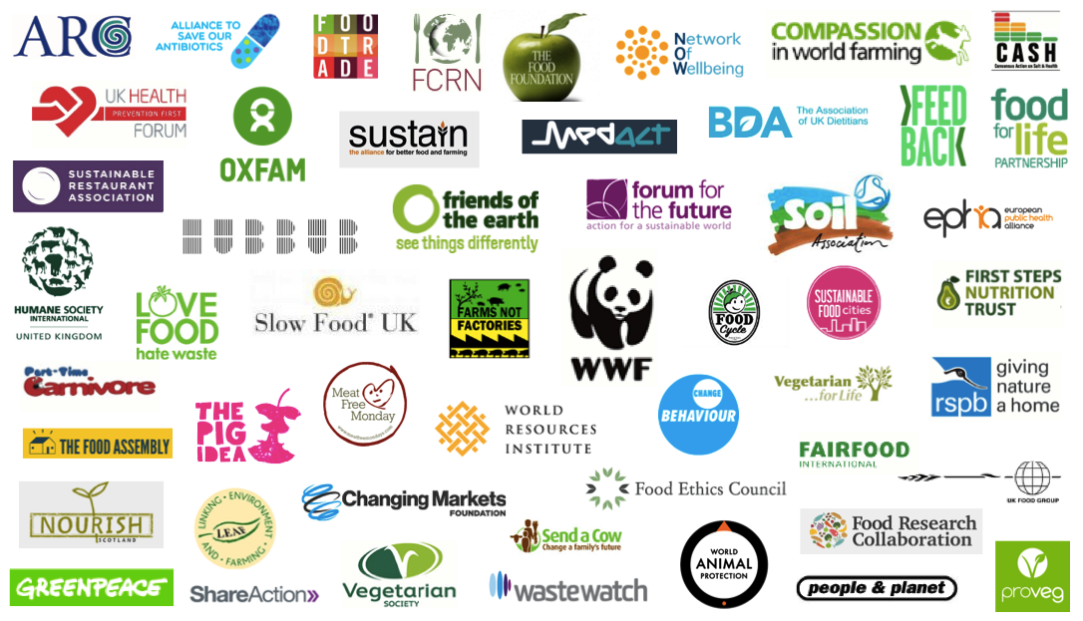

Our achievements to date include:

Engaging civil society
- Eating Better has built a strong and influential alliance of 52 organisations spanning an unrivalled breadth of expertise and interests. In addition to participating in alliance activities, we also encourage alliance organisations to develop their own initiatives that support Eating Better’s objectives.
- In our 2017 survey alliance organisations said they value being part of a movement that is working towards shared goals, where coming together means bigger impact and which enables organisations to set their own work in context. Our expertise is valued: eg “Eating Better is the 'go to organisation' for the latest developments in policy or market developments on the issue.” There was 97% agreement that Eating Better is helping NGO’s connect & collaborate and that we are enabling NGOs to be more confident in their own messaging/campaigns towards less & better meat/sustainable diets (94%).

Influencing policy makers
- Eating Better’s Eatwell for the Planet campaign was successful in achieving our priority policy goal to embed sustainability within the revised 2016 UK nutrition guidelines (the Eatwell Plate). Our Sustainable Dietary Guidelines briefing with MedAct (March 2017) sets out recommendations for further engaging public health institutions and professionals with coverage that included the BMJ.
- Our report: Beyond the CAP: policies to support better UK meat & dairy production post-Brexit
(2017) is providing evidence and thought leadership to inform reviews of the Common Agricultural Policy and post-Brexit policy towards sustainable livestock production and diets.
- Our 2016 Policy Recommendations Briefing developed in consultation with alliance organisations has ensured sustainable diets are central to alliance organisations’ own policy proposals.

Raising public awareness & developing behaviour change strategies
- Eating Better’s messaging of ‘less and better’ has underpinned the development of a new language and major new trend of ‘flexitarian’ eating in which meat eaters reduce their meat consumption, rather than cut it out completely. Our 2017 YouGov research shows that 44% of British people are willing or already committed to cutting down or cutting out meat.
- Our influential Let’s Talk About Meat: Changing dietary behaviour for the 21st Century research and report identifies 10 ways to motivate behaviour change towards less and better meat eating and identified gaps in research. Its findings were covered in the Guardian, extensively in the trade press and in Newsweek. It is a widely quoted reference and has stimulated further research in this area including by the Food Standards Agency: Our Food Future.
- Eating Better was selected by the marketing industry for its Do It Day Initiative to bring creatives together with good causes. The resulting Are you vegcurious? (November 2016) aimed at young men generated a suite of creative resources, an advertising campaign, a website (3.6K views and 2.3K users during the 4-week campaign), and a partnership with Hubbub and celebrated chef Bruno Loubet.
- Eating Better has become the ‘go to’ civil society partner and spokesperson for impactful initiatives that further our objectives including World Meat Free Day in 2015, 2016 and 2017 (social reach of over 82 million .and 2016 UN International Year of Pulses providing expertise, media and event spokesperson and civil society connections to increase the impact.
- Eating Better’s 2017 survey of our alliance organisations found 97% agreement that Eating Better is developing thinking about how best to encourage behaviour change towards more plant-based, less meat eating.

Influencing business practices
- We are helping to drive the flexitarian market by creating competition in the marketplace, demonstrating the market for less and better, showcasing companies leading the way and developing ‘how to’ advice for businesses and amplifying and supporting the work of Eating Better alliance organisations. In May 2017 we published The Future is Flexitarian: Companies leading the way which showcased over 20 companies including high street chains and supermarkets, that are leading the way to help people eat a greater variety of plant-based foods and less meat, and to support ‘better meat’ from farming that benefits the environment and animal welfare.
- In 2016 our Sandwiches unwrapped campaign encouraged supermarkets and high street sandwich chains to provide more meat-free lunchtime choices. The idea emerged from our behaviour change workshop, which identified eating a meat-free lunch as a key behaviour to support lower meat diets. We surveyed 12 supermarket & high street chains sandwich choices, engaged the public via #meatfreelunch and in 2016 we were able to congratulate Pret a Manger and M&S on providing a better range than their competitors.

Our objectives & activities in 2017 - 2020

Eating Better’s core workplan for 2017-2020 agreed with our funders, the Esmee Fairbairn Foundation, is organised under two outcomes:

- To mobilise civil society
Outcome: An engaged, effective and powerful broad-based civil society movement that is driving change for healthy and sustainable diets.

- To drive behaviour change towards sustainable diets with less and better meat
Outcome: Measurable shifts in public and business attitudes, and behaviours towards less and better meat/more plant-based eating.

Our goals within this period are to:

1. Mobilise civil society. In 2017-2020 we shall
- Build the capacity of the alliance and maintain the alliance engagement by connecting alliance organisations to our activities with quarterly internal updates, disseminating member campaign/event alerts, and amplifying member campaigns to wider audiences through our blogs, monthly newsletter and social media;
- Expand opportunities for dialogue: by providing a forum for alliance organisations to coordinate and amplify efforts, share learnings, and represent them as a powerful, unifying voice by hosting Eating Better’s annual alliance workshop and convening shared interest working groups. We will also provide new opportunities for dialogue by hosting roundtable events on tricky issues with invited experts to develop positions to influence policy, business practices and behaviour change strategies.
- Build alliance capacity: We will enable organisations to build capability and scale up relevant activities by providing advice and connections and practical resources.
- Influence policy: As Brexit will provide the policy context during this period, we will focus on feeding in the ‘sustainable diets’ element to policy and civil society initiatives, building on our Livestock Post Brexit work.
- Project development: we will use our core resources to scope and seek funding for at least 2 new collaborative projects.

2. Drive behaviour change towards sustainable diets with less and better meat
In 2017-2020 we shall:
- upgrade and develop our website to make it more accessible and relevant to different audiences (including food businesses and the public);
- develop new messaging for the Eating Better Challenge to halve people’s meat consumption and integrate messaging into all Eating Better communication channels including social media;
- raise public awareness and interest the media by undertaking an annual benchmarking survey, publish a report & host a high-level event that will provide new evidence/analysis of food businesses activity towards healthy & sustainable food.
- Grow our media impact and reach via mainstream and social media for our research and asks.
- Partner with selected initiatives to amplify Eating Better’s messages to a wider audience e.g. World Meat Free Day.

In addition to the core-funded work, we are seeking further funding to deliver discreet projects and campaigns to further Eating Better’s aims. We have a number of these at various stages of development, but there is potential for new ideas and approaches.

Staff team
The Executive Director leads a small staff team, comprising Campaigns and Communications Manager, Campaign Officer plus interns. Eating Better currently has office space in Old Street, London.

Funding & Governance
We are funded by grants. Our main funder is the Esmee Fairbairn Foundation and by funding and in-kind support from our alliance organisations. Our current 3-year funding from EFF runs until June 2020.

Eating Better is a registered charity (Charity Registration No: 1175669). Our Board of Trustees is chaired by Clare Oxborrow of Friends of the Earth.

The role of the Executive Director

The purpose of this role is to lead Eating Better and the development of the alliance and its impact, specifically to:
- Work with colleagues and the Board and alliance organisations to develop, deliver and monitor Eating Better’s strategy, priorities, annual workplans and impact.
- Ensure effective performance, including good financial planning, management of the organisation and reporting to the Board. Monitor progress, and provide the Board with progress reports, including finance reports and information to enable decision-making and good governance.
- Lead on Eating Better’s fundraising strategy to ensure sufficient funds for core activities and project development. Develop and maintain relationships with funders and coordinate and draft funding applications.
- Deliver outreach strategy to grow the alliance and its impact.
- Work with colleagues to develop, manage and implement projects as agreed with the Board.
- Establish research needs.
- Lead and develop organisational issue expertise and analysis, keep abreast of latest political and scientific developments and ensuring appropriate response, e.g. in the media, to influencers and in supporter communications etc.
- Manage and develop the Eating Better core team.
- Seek opportunities to represent Eating Better in the media, at high-level meetings and at events.
- Develop effective relationships within the alliance and with key external stakeholders to further Eating Better objectives.
- Undertake other duties as agreed with the Board.

Person Specification

Essential:
- Excellent organisational leadership and facilitation skills including 5 years senior management experience within civil society organisations.
- Excellent organisational management and planning skills.
- Excellent team management, and development skills
- Excellent oral and written communication skills, including presentation and media skills.
- Excellent communication and advocacy skills.
- Excellent analytical and strategic skills.
- Financial management skills.
- Good networking skills.
- Good IT and web management skills.
- The ability to work in the UK.

Knowledge
- Good understanding of sustainable food issues, the UK policy and business contexts and behaviour change.
- Knowledge of relevant stakeholder organisations.

Personal attributes
- Ability to work on own initiative, to prioritise own workload, set realistic timetables and meet deadlines.
- Ability to create effective and supportive team working.
- Ability to be credible, respected spokesperson for Eating Better.
- Committed to the aims of Eating Better.

Qualifications
- A minimum of a First degree or equivalent.
Experience
- Convening/facilitating alliance building.
- Senior level stakeholder engagement
- Developing and raising funds for new projects.
- Public speaking to policy, business and public audiences
- High profile media work
- Mediation or facilitation.

Desirable:
Higher level qualification
Understanding of relevant law and governance issues within a charity.

To Apply:
Send (by email) to Aileen Corrieri (aileen@eating-better.org)
- your CV
- a covering letter demonstrating how you meet the person specification requirements (no more than 3 pages)
- contact details of two people who can provide references for your work (we will not contact them without informing you first).

Closing date for applications: 12 noon, Monday 9 April 2018 (late applications will not be accepted).

First interviews will be held on Monday 23 April 2018 in London. Unfortunately we are unable to give feedback to candidates not invited to interview.

No agencies.

